Name: Kushagra Singh.
Roll. No. 244CA024

Operational Queries:

1. List all classrooms with a capacity greater than 50.

SELECT *
FROM classroom
WHERE capacity > 50;
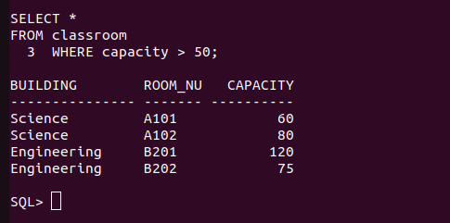

2. Find the names of all instructors in the "Computer Science" department.

SELECT name
FROM instructor
WHERE dept_name = 'Computer Science';

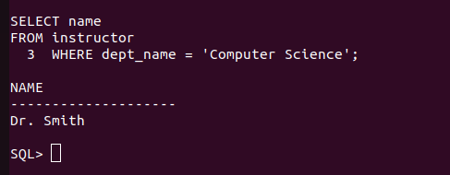

3. Retrieve the titles of all courses offered in the "Spring" semester of 2023.

SELECT title
FROM course c
JOIN section s ON c.course_id = s.course_id
WHERE s.semester = 'Spring' AND s.year = 2023;

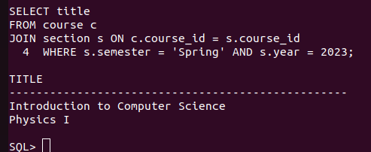

4. List all students who have taken more than 100 total credits.

SELECT name
FROM student
WHERE tot_cred > 100;



5. Find the names of all departments with a budget greater than ₹1,000,000.

SELECT dept_name
FROM department
WHERE budget > 1000000;


6. List all departments and their respective buildings.

SELECT dept_name, building
FROM department;

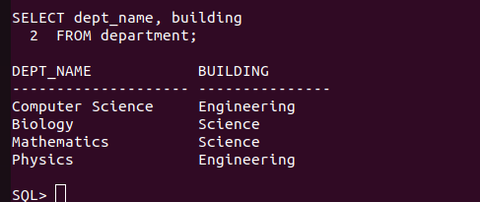

7. Find the names of all students enrolled in the "Biology" department.

SELECT name
FROM student
WHERE dept_name = 'Biology';



8: Retrieve the titles of all courses with 3 credits.
SELECT title
FROM course
WHERE credits = 3;



9. List all instructors who do not belong to any department.

SELECT name
FROM instructor
WHERE dept_name IS NULL;



10. Find the total number of classrooms in each building.

SELECT building, COUNT(*) AS total_classrooms
FROM classroom
GROUP BY building;
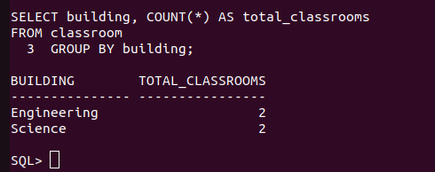

11. List all courses taught by the instructor with ID "10101".

SELECT c.title
FROM course c
JOIN teaches t ON c.course_id = t.course_id
WHERE t.ID = '10101';

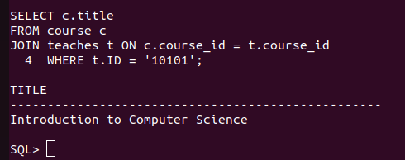

12. Find the total number of students enrolled in each department.

SELECT dept_name, COUNT(*) AS total_students
FROM student
GROUP BY dept_name;

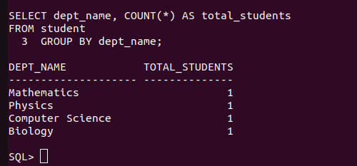

13. Retrieve the names of students who have taken the course "CS-101" and received an "A" grade.

SELECT s.name
FROM student s
JOIN takes t ON s.ID = t.ID
WHERE t.course_id = 'CS-101' AND t.grade = 'A';

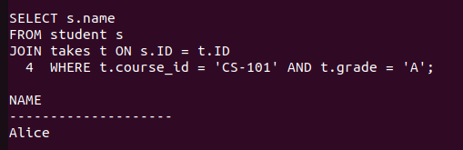

14. List all instructors who earn a salary greater than ₹50,000.

SELECT name
FROM instructor
WHERE salary > 50000;



15. Find the average salary of instructors in each department.

SELECT dept_name, AVG(salary) AS average_salary
FROM instructor
GROUP BY dept_name;

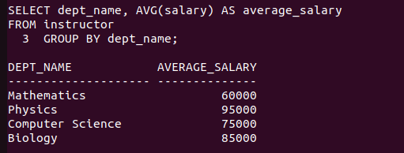

16. Retrieve the names of students who have not been assigned an advisor.

SELECT s.name
FROM student s
LEFT JOIN advisor a ON s.ID = a.s_ID
WHERE a.i_ID IS NULL;



17. List all courses that have "CS-101" as a prerequisite.

SELECT c.title
FROM course c
JOIN prereq p ON c.course_id = p.course_id
WHERE p.prereq_id = 'CS-101';

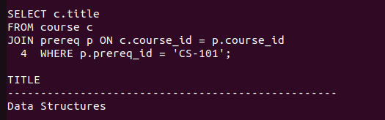

18. Find the total number of sections taught in each building.

SELECT s.building, COUNT(*) AS total_sections
FROM section s
GROUP BY s.building;

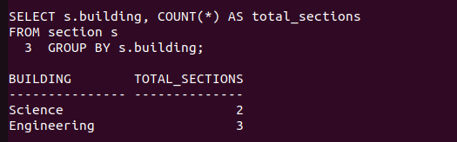

19. Retrieve the names of students who have taken at least one course in the "Fall" semester of 2022.

SELECT DISTINCT s.name
FROM student s
JOIN takes t ON s.ID = t.ID
JOIN section sec ON t.course_id = sec.course_id
WHERE sec.semester = 'Fall' AND sec.year = 2022;

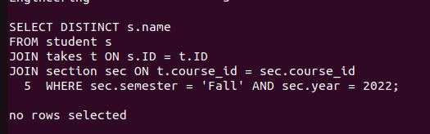

20. List all classrooms that have not been assigned to any section.

SELECT *
FROM classroom
WHERE (building, room_number) NOT IN (SELECT building, room_number FROM section);

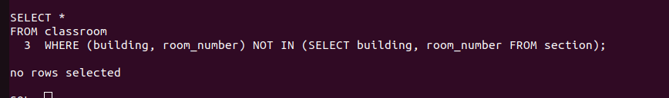

21. List all courses offered by the "Mathematics" department.

SELECT title
FROM course
WHERE dept_name = 'Mathematics';



22. Find the names of students who have taken courses in both "Fall" and "Spring" semesters.

SELECT DISTINCT s.name
FROM student s
JOIN takes t ON s.ID = t.ID
JOIN section sec ON t.course_id = sec.course_id
WHERE sec.semester = 'Fall' AND EXISTS (
SELECT 1
FROM section sec2
WHERE sec2.course_id = t.course_id AND sec2.semester = 'Spring' AND sec2.year = sec.year
);

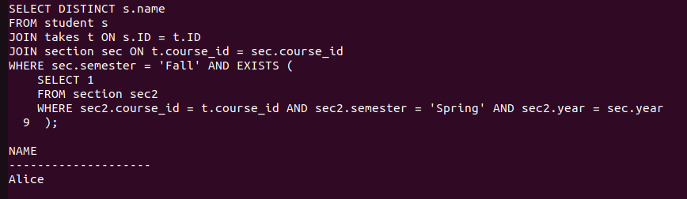

23. Retrieve the names of instructors who have taught more than 5 sections.

SELECT i.name
FROM instructor i
JOIN teaches t ON i.ID = t.ID
GROUP BY i.name
HAVING COUNT(t.course_id) > 5;



24. List all courses that have no prerequisites.

SELECT title
FROM course
WHERE course_id NOT IN (SELECT course_id FROM prereq);

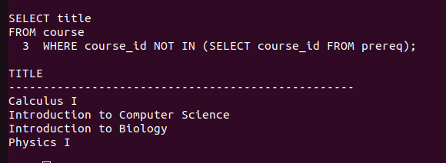

25. Find the average number of credits taken by students in each department.

SELECT s.dept_name, AVG(tot_cred) AS avg_credits
FROM student s
GROUP BY s.dept_name;

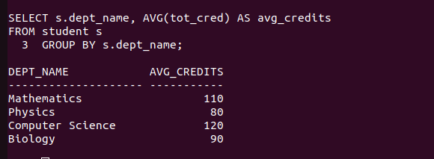

26. Retrieve the names of students who have taken courses with the instructor "Einstein".

SELECT DISTINCT s.name
FROM student s
JOIN takes t ON s.ID = t.ID
JOIN section sec ON t.course_id = sec.course_id
JOIN teaches te ON sec.course_id = te.course_id AND sec.sec_id = te.sec_id
JOIN instructor i ON te.ID = i.ID
WHERE i.name = 'Einstein';

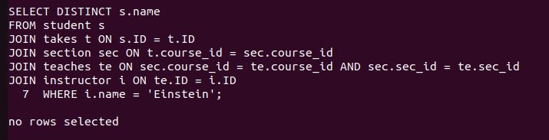
27. List all sections that are held in the "Watson" building.

SELECT DISTINCT sec.course_id, sec.sec_id, sec.semester, sec.year
FROM section sec
WHERE sec.building = 'Watson';

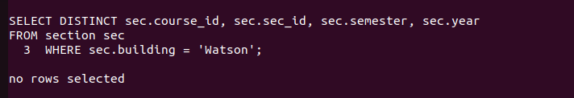

28. Find the total budget allocated to all departments.

SELECT SUM(budget) AS total_budget
FROM department;



29. Retrieve the names of students who have taken at least one course with a grade of "B".

SELECT DISTINCT s.name
FROM student s
JOIN takes t ON s.ID = t.ID

WHERE t.grade = 'B';
30. List all instructors who have not taught any courses.

SELECT i.name
FROM instructor i
LEFT JOIN teaches t ON i.ID = t.ID
WHERE t.course_id IS NULL;



31. Find the names of students who have taken all courses offered by the "Computer Science" department.

SELECT s.name
FROM student s
WHERE NOT EXISTS (
SELECT c.course_id
FROM course c
WHERE c.dept_name = 'Computer Science' AND NOT EXISTS (
SELECT t.course_id
FROM takes t
WHERE t.ID = s.ID AND t.course_id = c.course_id
)
);

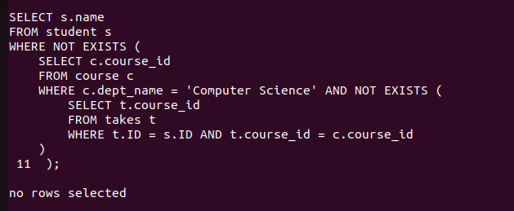

32. Retrieve the names of instructors who have taught every course in their department.

SELECT i.name
FROM instructor i WHERE NOT EXISTS (SELECT c.course_id FROM course c WHERE c.dept_name = i.dept_name AND NOT EXISTS (SELECT 1 FROM teaches t WHERE t.ID = i.ID AND t.course_id = c.course_id));

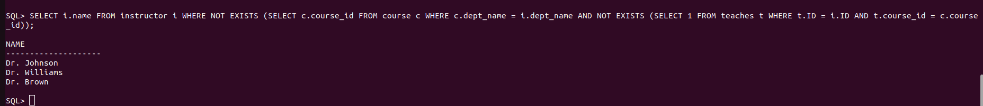

33. List all students who have taken at least one course with every instructor in their department.

SELECT s.name
FROM student s
WHERE NOT EXISTS (
SELECT i.ID
FROM instructor i
WHERE i.dept_name = s.dept_name
AND NOT EXISTS (
SELECT 1
FROM takes t
JOIN section sec ON t.course_id = sec.course_id
JOIN teaches te ON sec.course_id = te.course_id
WHERE t.ID = s.ID AND te.ID = i.ID
)
);

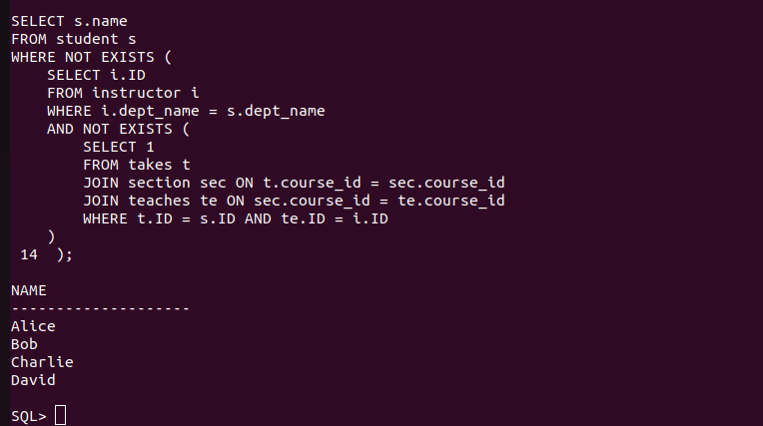

34. Find the courses that have the highest number of prerequisites.

SELECT c.title
FROM course c
WHERE (SELECT COUNT(*) FROM prereq p WHERE p.course_id = c.course_id) = (
SELECT MAX(prereq_count)
FROM (SELECT COUNT(*) AS prereq_count FROM prereq GROUP BY course_id)
);

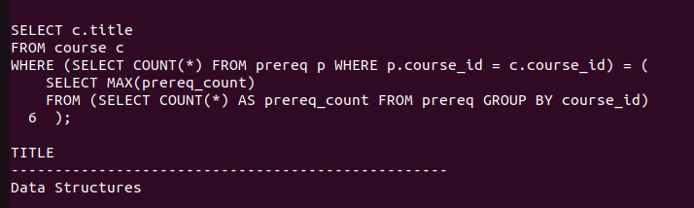

35. Retrieve the names of students who have taken the same course more than once.

SELECT DISTINCT s.name
FROM student s
JOIN takes t ON s.ID = t.ID
GROUP BY s.name, t.course_id
HAVING COUNT(t.course_id) > 1;



36. List all instructors who have taught in every semester (Fall, Winter, Spring, Summer) in the year 2023.

SELECT DISTINCT i.name
FROM instructor i
WHERE NOT EXISTS (
SELECT semester
FROM (SELECT 'Fall' AS semester FROM dual UNION ALL SELECT 'Winter' FROM dual UNION ALL SELECT 'Spring' FROM dual UNION ALL SELECT 'Summer' FROM dual) all_semesters
WHERE NOT EXISTS (
SELECT 1
FROM teaches t
JOIN section sec ON t.course_id = sec.course_id
WHERE t.ID = i.ID AND sec.year = 2023 AND sec.semester = all_semesters.semester
)
);
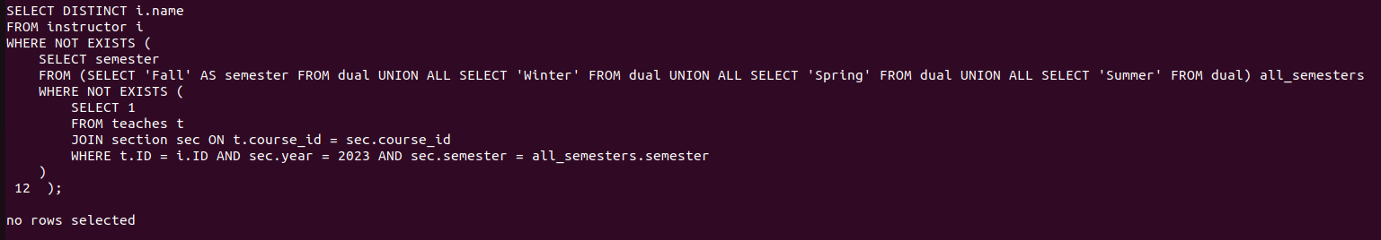

37. Find the departments where the average instructor salary is greater than the overall average salary.

SELECT d.dept_name
FROM department d
JOIN instructor i ON d.dept_name = i.dept_name
GROUP BY d.dept_name
HAVING AVG(i.salary) > (SELECT AVG(salary) FROM instructor);

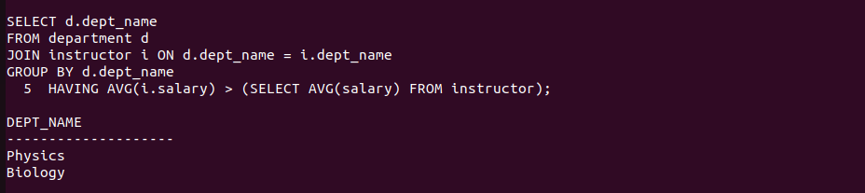

38. Retrieve the names of students who have taken courses in all available time slots.

SELECT s.name
FROM student s
WHERE NOT EXISTS (
SELECT ts.time_slot_id
FROM time_slot ts
WHERE NOT EXISTS (
SELECT 1
FROM takes t
JOIN section sec ON t.course_id = sec.course_id
WHERE t.ID = s.ID AND sec.time_slot_id = ts.time_slot_id
)
);

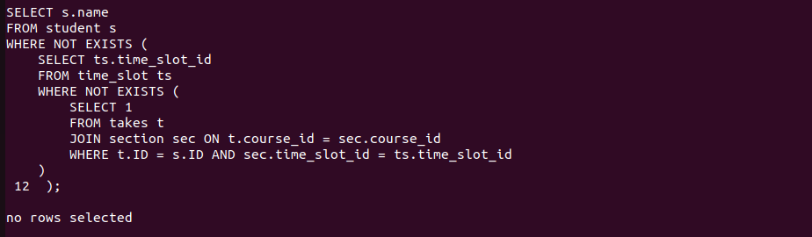

39. List all courses that have no prerequisites but are prerequisites for other courses.

SELECT c.title
FROM course c
WHERE NOT EXISTS (SELECT 1 FROM prereq p WHERE p.course_id = c.course_id)
AND EXISTS (SELECT 1 FROM prereq p WHERE p.prereq_id = c.course_id);



40. Find the students who have taken the most number of courses in a single semester.

SELECT s.name
FROM student s
JOIN takes t ON s.ID = t.ID
GROUP BY s.name, t.semester, t.year
HAVING COUNT(t.course_id) = (
SELECT MAX(course_count)
FROM (SELECT COUNT(course_id) AS course_count FROM takes GROUP BY ID, semester, year)
);

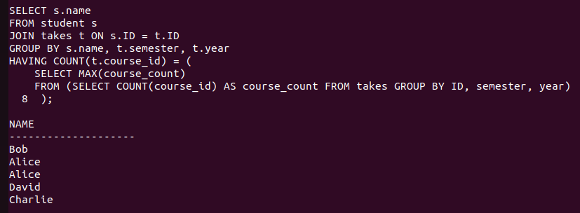

41. Find the students who have taken courses from all departments.

SELECT s.name
FROM student s
WHERE NOT EXISTS (
SELECT d.dept_name
FROM department d
WHERE NOT EXISTS (
SELECT 1
FROM takes t
JOIN section sec ON t.course_id = sec.course_id
WHERE t.ID = s.ID AND sec.course_id IN (SELECT course_id FROM course WHERE dept_name = d.dept_name)
)
);
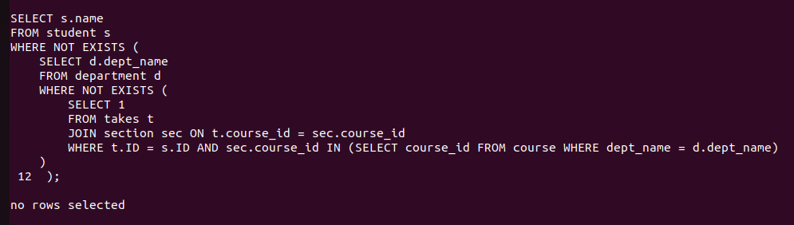

42. Retrieve the names of instructors who have taught the same course in multiple semesters.

SELECT DISTINCT i.name
FROM instructor i
JOIN teaches t ON i.ID = t.ID
JOIN section sec ON t.course_id = sec.course_id
GROUP BY i.name, t.course_id
HAVING COUNT(DISTINCT sec.semester) > 1;

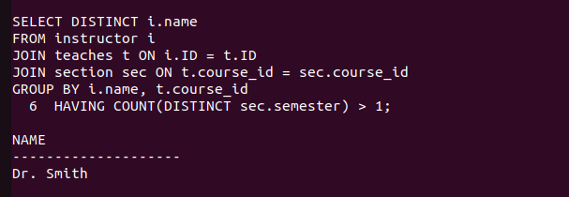

43. List all courses that are prerequisites for more than 3 other courses.

SELECT c.title
FROM course c
WHERE (SELECT COUNT(*) FROM prereq p WHERE p.prereq_id = c.course_id) > 3;

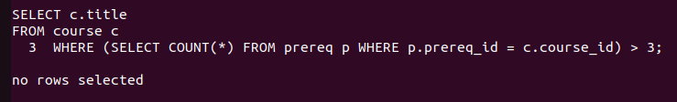

44. Find the departments where the total student credits exceed the department budget.

SELECT d.dept_name
FROM department d
JOIN student s ON s.dept_name = d.dept_name
GROUP BY d.dept_name, d.budget
HAVING SUM(s.tot_cred) > d.budget;


45. Retrieve the names of students who have taken courses with every instructor in their department.

SELECT s.name
FROM student s
WHERE NOT EXISTS (
SELECT i.ID
FROM instructor i
WHERE i.dept_name = s.dept_name
AND NOT EXISTS (
SELECT 1
FROM takes t
JOIN section sec ON t.course_id = sec.course_id
JOIN teaches te ON sec.course_id = te.course_id
WHERE t.ID = s.ID AND te.ID = i.ID
)
);

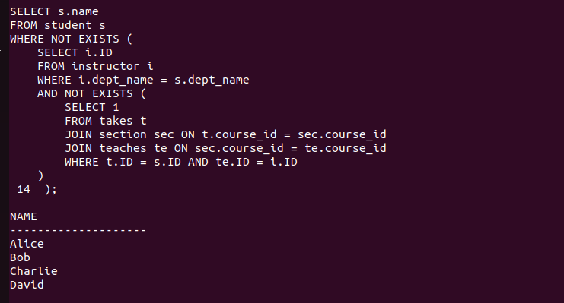

46. List all courses that have been taught in every semester.

SELECT c.title
FROM course c
WHERE NOT EXISTS (
SELECT semester
FROM (SELECT 'Fall' AS semester FROM dual UNION ALL SELECT 'Winter' FROM dual UNION ALL SELECT 'Spring' FROM dual UNION ALL SELECT 'Summer' FROM dual) all_semesters
WHERE NOT EXISTS (
SELECT 1
FROM section sec
WHERE sec.course_id = c.course_id AND sec.semester = all_semesters.semester
)
);

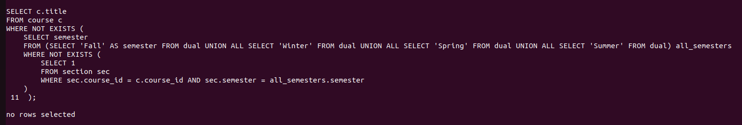
47. Find the students who have taken the most number of courses overall.

SELECT s.name
FROM student s
JOIN takes t ON s.ID = t.ID
GROUP BY s.name
ORDER BY COUNT(t.course_id) DESC
FETCH FIRST 1 ROWS ONLY;

.
.
.
.
.
.
.
.
.
.
.
.
output image goes here for query number 47.
.
.
.
.
.
.
.
.
.
.
.
.

48. Retrieve the names of instructors who have taught courses in all buildings.

SELECT DISTINCT i.name
FROM instructor i
JOIN teaches t ON i.ID = t.ID
JOIN section sec ON t.course_id = sec.course_id
JOIN classroom c ON sec.building = c.building
GROUP BY i.name
HAVING COUNT(DISTINCT sec.building) = (SELECT COUNT(DISTINCT building) FROM classroom);

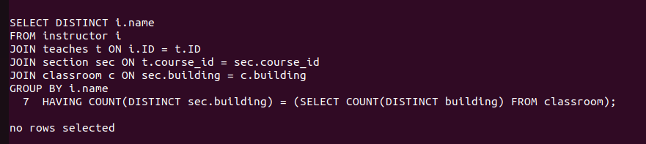

49. List all students who have taken courses with overlapping time slots.

SELECT DISTINCT s.name
FROM student s
JOIN takes t ON s.ID = t.ID
JOIN section sec ON t.course_id = sec.course_id
JOIN time_slot ts1 ON sec.time_slot_id = ts1.time_slot_id
JOIN section sec2 ON sec.course_id = sec2.course_id
JOIN time_slot ts2 ON sec2.time_slot_id = ts2.time_slot_id
WHERE t.ID = s.ID AND sec.course_id != sec2.course_id
AND ts1.day = ts2.day
AND (
(ts1.start_hr < ts2.end_hr AND ts1.start_min < ts2.end_min) OR
(ts2.start_hr < ts1.end_hr AND ts2.start_min < ts1.end_min)
);

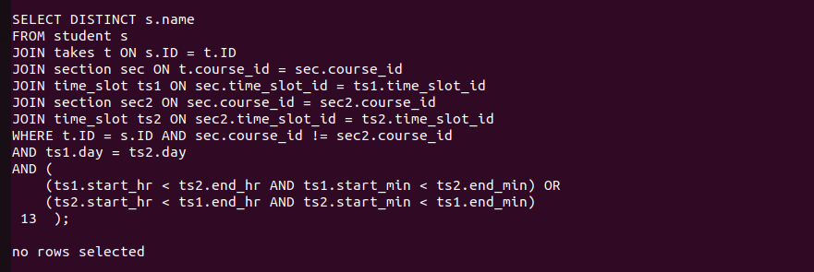

50. Find the courses that have the highest enrollment across all semesters.

SELECT c.title
FROM course c
WHERE c.course_id = (
SELECT course_id
FROM section sec
JOIN takes t ON sec.course_id = t.course_id
GROUP BY sec.course_id
ORDER BY COUNT(t.ID) DESC
FETCH FIRST 1 ROWS ONLY
);

.
.
.
.
.
query 50 is not working.
Output image will be here.
.
.
.
.
.
.

